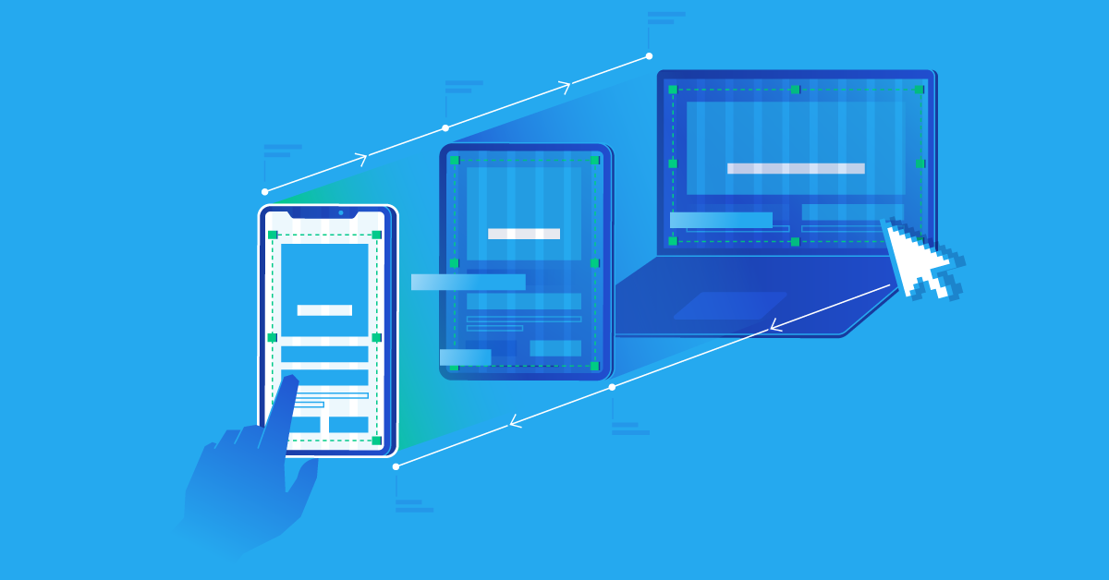

**Responsive design**

**Responsive design** is a graphic user interface design approach used to create content that adjusts smoothly to various screen sizes. Designers size elements in relative units and apply media queries, so their designs can automatically adapt to the browser space to ensure content consistency across devices

**Why response design is so popular**

In the early 2010s , designers had to address a historic phenomenon .more users were starting to access web material on handheld devices that on desktops. There were two main solutions. designers could craft several versions of one design and make each have fixed dimensions. alternatively , they could work on a single flexible design that would stretch or shrink to fit the screen .organizations and designers found the benefits of responsive design hard to ignore .rather can work with absolute units(eg pixels )

**The responsive design approach :**

**There are two essential factors designers must consider for responsive web design :**

* Break points
* Visual content

# **Break points**

Designers must identify these breakpoints and optimize layouts to match multiple devices during the UX design process. In most cases. Designers only have to consider three viewpoints:

* Smartphones/mobile 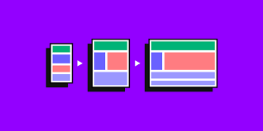
* Tablet
* Desktop

But, for a website to be fully responsive, designers should also consider both portrait and landscape layouts for mobile and tablet for a total of five breakpoints .

* Smartphone/mobile-portrait
* Smartphone/mobile landscape
* Tablet -portrait
* Desktop

# **Visual content**

Visual content includes images, videos, and GIFS . these visuals take up a lot of resources and can take a long time to load on mobile devices, so designers must compress and optimize visual content to reduce the file size.

**Examples of responsive design:**

**The Guardian**

The guardian is a famous British with a strong online presence and an excellent example of mobile -first design consistency. In keeping with our mobile- first approach , lets start the guardians analysis with the smallest screen :

**Smartphone view**

The smartphone view is and inviting with all the essential elements presented in a clear visual hierarchy .

* At the top the necessities are in the banner , with login , search and the sites title .
* Directly below are the most popular navigation categories (home, “US” “world”, etc) for easy access. The guardian hides additional navigation links behind the hamburger menu
* The features story takes up most of the room with its enticing image, showing that it’s the most important element.
* The user can access multiple secondary stories making headlines with a quick scroll , thus facilitating browsing and giving users control.

No space is wasted on the mobile version , too-even the whitespace opposite the “headlines” title features weather information , providing extra value to mobile users.

**Tablet view**

* Above the user interface on the tablet view the guardian includes an ad for business value.
* At the top, the banner remains the same, but the tablet view offers more room for additional elements, labels for the icons, and the guardian’s subheading below the logo.
* The most significant difference is that the tablet shows more stories and increases from a single column to four. This creative use of the card UI pattern allows the designers to prioritize stories using a size hierarchy.

**Desktop view**

* The desktop view reveals the true mastery of the Guardian’s website. The site is consistent across all three screen sizes, giving readers the same user experience no matter what device they’re using.
* Each version is scroll-based, uses the same card components with similar header navigation and branding. The only significant difference is the number of stories per screen size.

**Smart phone view**

**Smashing magazine**

[Smashing Magazine](https://www.smashingmagazine.com/) does well to follow its own advice on creating better mobile experiences with a fully responsive website.

* The header is simple with the brand’s logo, search icon, and clearly labeled menu to open the navigational drawer.
* Smashing Magazine shows its latest article with relevant metadata, and except.
* Smashing Magazine makes it obvious that you must scroll to see more content on the home page.